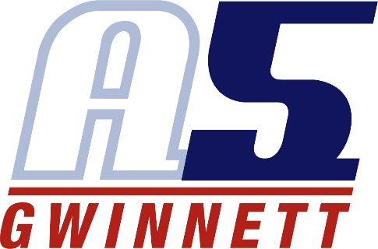
Angela Clark

Coaching Experience:

A5 Gwinnett Volleyball Club, Suwanee, GA (2012 – Present)
o Assistant Coach, 18-1 April (2013-Present)
▪ 2018 Music City National Qualifier Champion
▪ 2018 Beast of the Southeast Qualifier Champion
▪ 2018 3rd SRVA Bid Tournament
▪ 2018 Ranked 5TH in SRVA 18 Power Rankings
▪ 2018 Earned 4 USAV Bids to Nationals
▪ 2017 Music City National Qualifier Champion
▪ 2017 Rally Rumble Power Champion
▪ 2017 3rd Northern Lights Qualifier
▪ 2017 USAV Bid to Nationals
▪ 2016 JJVA Winter Blast Champions
▪ 2016 USAV Bid to Nationals
▪ 2015 SRVA 18 Power Champions
▪ 2015 First Lady Challenge 18 Power Champions
▪ 2015 USAV Bid to Nationals
▪ 2015 2nd in 18 American Big South National Qualifier
▪ 2015 5th in 18 American Colorado Crossroads National Qualifier
▪ Finished 5th in SRVA 18 Power Rankings in 2015
▪ 2014 First Coast Festival Champions

○ Assistant Coach, 14-1 April (2017 – Present)
▪ 2018 Dogwood Donnybrook Champions
▪ 2018 JJVA Jax Jam 2nd Place
▪ 2017 Kudzu Klassic Power Champions
▪ 2017 K2 Clash Champions
▪ 2017 BVC Bash 2nd place

o Assistant Coach, 15-1 Bryan (2012-2013)
   ▪ USAV Bid Nationals

Peachtree Ridge High School, Suwanee, GA (2016 - Present)
○ Head Coach, JV
Kings Ridge Christian School, Milton, GA (2014- 2016))
o Assistant Coach, Varsity
Certification
o USA Volleyball Impact Certified
○ GHSA

Playing Experience:
United States Army
1990-1992 Frankfurt GE OS/RS
1992 All Army Volleyball team OH/RS
Competed in the Georgia Games for 2 years
High School All City OH & Captain for 2 years
Played several women’s leagues and coed leagues

Education:
BS. Electronic Engineering 10/25/1996
MIS Information Systems Management 12/20/2012
Six Sigma Green Belt

