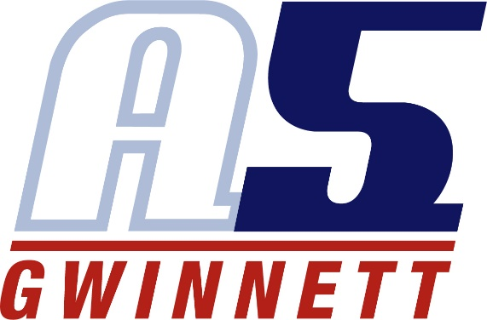

Lindsay Holmes

Coaching Experience

A5 Gwinnett Volleyball Club (GA5) – Suwanee, GA 2018-2019 Season
- 16-2 Assistant Coach

A5 Gwinnett Volleyball Club (GA5) – Suwanee, GA 2017-2018 Season
- 12-2 Head Coach

Norcross High School – Norcross, GA 2017 Fall Season
- Assistant Freshman Coach
- Gwinnett County Tournament Runner-Up

Georgia College and State University – Milledgeville, GA June 2013-July 2016
- Volleyball Camp Counselor

Playing Experience
Georgia College and State University – Milledgeville, GA
- Defensive Specialist
- Played All 4 Years
- Played 82 of 115 Matches
- Senior Captain

Norcross High School – Norcross, GA
- Libero
- All 4 Years in the Volleyball Program, 2 Years on Varsity
- 2 Years as Varsity Captain
- Best Defensive Player 2009, 2010, 2011
- Nelson Award 2012
- All Area 1st Team 2012, GVCA All Area 2nd Team 2012

GA5 – Suwanee, GA November 2012-June 2013
- Libero
- 18-1 with Coach April Carroll

Atlanta Extreme Volleyball Club – Suwanee, GA November 2011-April 2012
- Libero
- 18-1 with Coach Kami Fongbemi

Education
Georgia College and State University – Milledgeville, GA
- Graduated May of 2017
- Bachelors in Science
  - Major: Exercise Science
  - Minor: Physical Education

Norcross High School – Norcross, GA
- Graduated May of 2013
- IB Certificate Recipient
- 200+ Hours of Community Service

