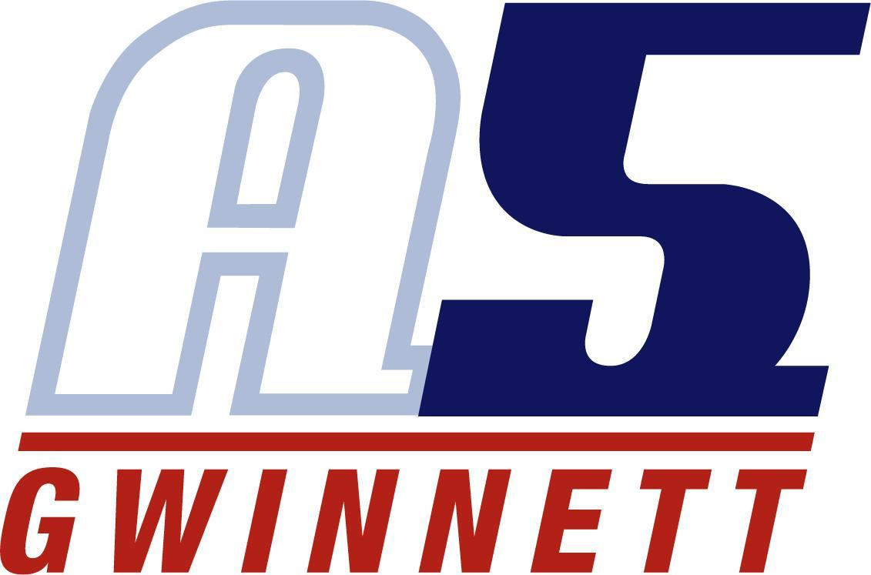

Haley DeSales

- Collegiate Coaching (2019-2023)
  - Tennessee Tech (indoor & beach)
  - Oregon State
  - Concordia University, Irvine

- Club Coaching (2014-Present)
  - Prime Volleyball Club
    - Head coach in 11’s & 15’s age groups
  - Forza1 West Volleyball Club

- Accomplishments
  - AVCA Thirty Under 30, Beach Award Winner – 2023
  - All Big West First Team – 2017, 2018
  - #6 for single-season digs at UC Irvine - 2018

- Playing Career & Education
  - Played at UC Irvine and Washington State
    - 2015- WSU, outside hitter
    - 2016-2018- UCI, outside hitter & libero
  - Earned a Bachelor’s in Education Sciences from UC Irvine in 2019
  - Earned a Master’s in Education from Concordia University, Irvine in 2022

