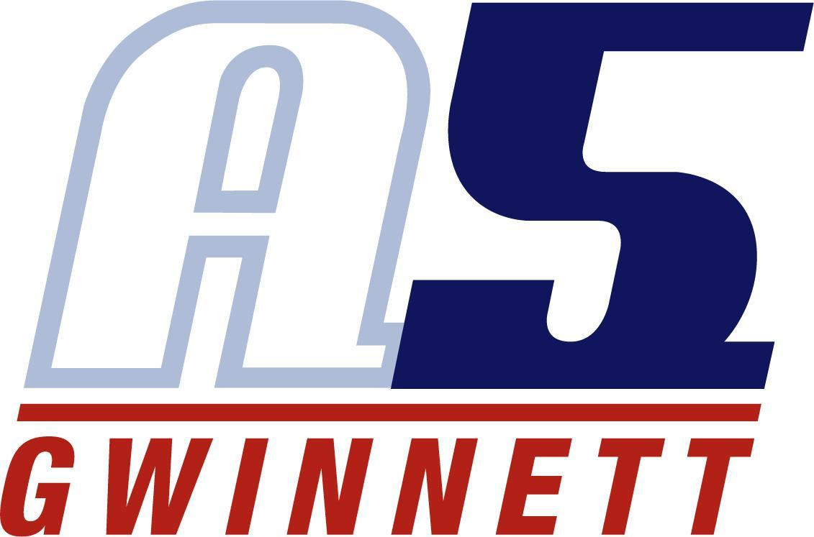

Marina Dixon

Experience
Years Coaching- 2016- current
- 2 years at Intensity Volleyball Club as 14-3s head coach (2021-2023)
- Co-head coach for Northview High school girls Varsity (2021, 2023)
- Northview High School Junior Varsity head coach (2021)
- Middle School (2018)
- And has coached various teams for the YMCA, local recreation teams.
About me
I have played volleyball since sixth grade for recreation teams, club teams, and high school.
I am very excited to continue my coaching career with A5G and have the opportunity to pass on what I have learned for the game I have grown to love and appreciate, and that has given me so much.
I am currently enrolled with Southern New Hampshire University in their sports management program. I also work part time as a server at a local sports bar.
Coaching accomplishments
- 1st round of state as a first-year coach
- 2nd place at SRVA regionals in 2023
- Been top three finalist for assistant coach of the year for the past 3 years

