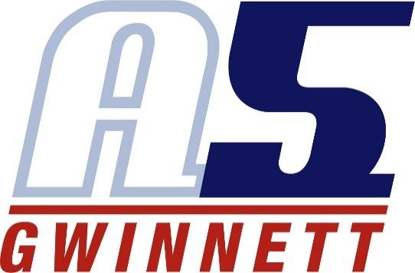

**Morgan Furness**

**COACHING EXPERIENCE**

* NAVC Assistant Coach (2019-2020)
* A5 Gwinnett 14-2 Regional Head Coach (2021-2022)
* A5 Gwinnett 15-1 Regional Head Coach (2023-2024)
* A5 Gwinnett 14-1 National Head Coach (2024-Current)
* Mill Creek 9th Grade Head Coach (2024-Current)

**PLAYING EXPERIENCE**

* Campbellsville University (2023)
  + Starting MB
  + 1X All Academic Conference Team
* Life University (2019–2022)
  + Starting MB
  + Captain Jr/Sr years
  + 3X All Academic Conference Team
* Mountain View High School (2015-2019) (MB/OH)
  + All County 1st Team (OH)
  + All Region (2018) (OH)
* A5 Gwinnett Volleyball Club (2016-2019)
  + MB 16-2
  + MB 17-2
  + MB 18-1

**EDUCATION**

* Bachelors in Business Administration with a Minor in Sports Management
  + Valedictorian, Summa Cum Laude, Class of December 2022
* Masters in Marketing, 4.0 GPA, Class of December 2023