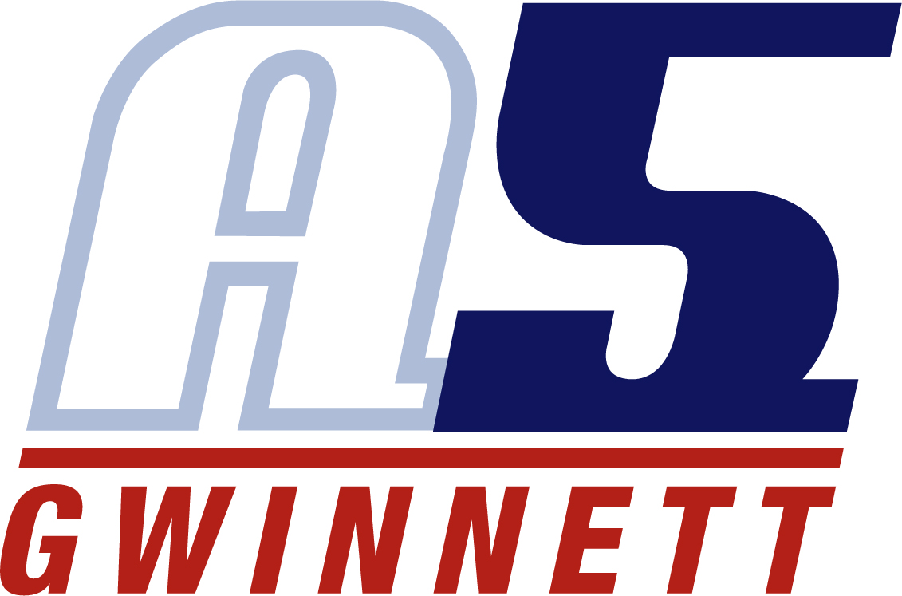

April L. Mifflin – Director/Head Coach
Master Coach/Recruiting Coordinator

Coaching Experience
- A5 Gwinnett Volleyball Club, Suwanee, GA (2010 – Present)
  - Director / Recruiting Coordinator (2012 – Present)
  - Head Coach, 18-1 & Master/Lead Coach (2012 – Present)
    - 2024 Block & Roll Invitational Champions
    - 2023 USAV Bid to Nationals
    - 2022 USAV Bid to Nationals
    - 2022 Bronze Molten Pre-Qualifier
    - 2021 USAV Bid to Nationals
    - 2021 Jacksonville Jam Champions
    - 2020 USAV Bid to Nationals
    - 2020 Jacksonville Jam Champions
    - 2019 5th in 18 American Music City Qualifier
    - 2019 5th in Northeast Qualifier
    - 2018 Music City National Qualifier Champion
    - 2018 Beast of the Southeast Qualifier Champion
    - 2018 3rd SRVA Bid Tournament
    - 2018 Ranked 5TH in SRVA 18 Power Rankings
    - 2018 Earned 4 USAV Bids to Nationals
    - 2017 Music City National Qualifier Champion
    - 2017 Rally Rumble Power Champion
    - 2017 3rd Northern Lights Qualifier
    - 2017 USAV Bid to Nationals
    - 2017 Trained AAU All American
    - 2017 Trained Pre-Season Gwinnett Super Six
    - 2016 – Qualified for USAV Nationals in 18 American
    - 2016 – JJVA Winter Blast Champions
    - 2016 – Trained Pres-Season Gwinnett Super Six
    - 2015 SRVA 18 Power Champions
    - 2015 First Lady Challenge 18 Power Champions – qualified for USAV Nationals in 18 Nationals Division
    - 2015 2nd in 18 American Big South National Qualifier
    - 2015 5th in 18 American Colorado Crossroads National Qualifier
    - Finished 5th in SRVA 18 Power Rankings in 2015
    - 2014 First Coast Festival Champions
  - Head Coach, 14-1 & Master Coach (2016 – Present)
    - 2024 SVT Southern Championship Champions
    - 2023 Kudzu Klassic Champions
    - 2023 16 Club Champions – Peach State Tour
    - 2020 Peach State Tour – 16 Club Division Champions
    - 2019 Smokey Mountain Challenge Champions
    - 2019 Dogwood Donnybrook Champions
    - 2018 Dogwood Donnybrook Champions
    - 2018 JJVA Jax Jam 2nd Place
    - 2017 Kudzu Klassic Power Champion
    - 2017 K2 Clash Champion
    - 2017 BVC Bash 2nd place
  - Co-Director / Director of Administration/ Recruiting Coordinator (2011 – 2012)
  - Head Coach, 17-1 & Master Coach (2011 – 2012)
  - Head Coach, 16-1 & Master Coach (2010 – 2011)
- Norcross High School, Norcross, GA (2013 - 2018)
  - Varsity Assistant Coach (2015-2018)
    - 2017 – Finished n Elite 8
    - 2016 – Area Champion
    - 2016 – Finished in Elite 8 in State
    - 2015 – Area Champions
    - 2015 – Finished in Elite 8 in State
  - Freshmen Head Coach (2013-2015)
    - 2013 Gwinnett County Champions
    - 2014 Gwinnett Area Champions
- West Suburban Volleyball Club, Wheaton, IL (2003 - 2005)
  - Head Coach, West Suburban Volleyball Club 17-1
  - Head Coach, West Suburban Volleyball Club 18-1
  - Help secure scholarships to Division I programs including University of Kentucky, Marquette, University of Rhode Island, University of Miami and University of Cincinnati
- Atlanta Boom Volleyball Institute, Atlanta, GA (2005 - 2010)
  - Assistant Coach, Atlanta Boom 18 Diamond
  - Head Coach, Atlanta Boom 16 Diamond
  - Head Coach, Atlanta Boom 17 Diamond
  - Head Coach, Atlanta Boom 15 Orange
  - Head Coach, Atlanta Boom 15 Diamond
  - Assistant Coaching Director
- Coached at various camps and personal training sessions

Playing Experience
- Norfolk State University (Norfolk, VA)
  - Captain of the team for 3 years
  - Most Valuable Player for 2 seasons
  - Named Norfolk State Female Athlete of the Year presented by ESPN’s broadcaster, Mike Tirico
  - Received All-Academic Award for 3 straight seasons
  - Member of Women’s Basketball Team
- North Side High School
  - Varsity Starter for Volleyball Team for 3 straight years
  - Varsity Starter for Basketball Team for 3 straight years
  - Varsity Member of the Track Team for 4 straight years
  - Only 1 of 2 women athletes to receive the All-Sports Letterman Award for being named for excellence in 3 different sports
- USA Volleyball Nationals and various other adult leagues

Other Information
- Official Atlanta Vibe Professional League
- Official Scorekeeper, Kennesaw State University since inaugural season
- Official Scorekeeper at Georgia Tech University
- Certified Line Judge & Certified Scorekeeper

Education
- Bachelors of Science, Chemistry – Norfolk State University, Magna Cum Laude
- Masters of Science, Chemistry – Loyola University Chicago, Summa Cum Laude
- Regulatory Affairs Certification – University of Georgia

