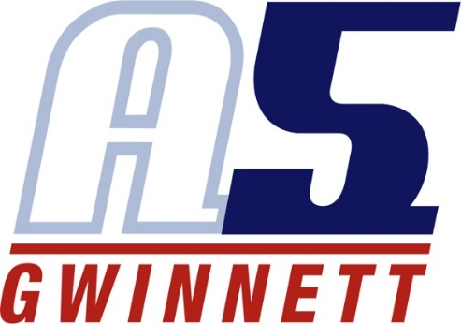
Sam Clark

Coaching Experience
A5 Volleyball Club - Assistant Coach, 13 Danielle, 2021 - 2022
- Gold medal at Rumble Rally
- Champions at Lucky Leprechaun
- Champions at Peachtree Classic
- Finished 3rd at Lil Big South
- Finished 3rd at Rally Challenge
- Finished 3rd at Dogwood Donnybrook
- Champions at Red Top Rally
- Made it to the gold bracket at AAUs

A5 Volleyball Club - Assistant Coach, 14 Alex, 2020-2021
• Finished 3rd at Peachtree Classic
• Champions at Lucky Leprechaun
• Finished 2nd at the Winter’s End Tournament

Playing Experience
• University of North Georgia Club Volleyball Team, 2014 - 2015
- Cambridge HS Varsity Volleyball Team, 2012 - 2013
- Milton HS JV Volleyball Team, 2009 - 2011
- Tsunami Volleyball Club, 2007 - 2008
- A5 Gwinnett (Formerly GA5), 2006 - 2007
- A5 Volleyball Club, 2004 - 2006
- Peachstate Juniors 2003 - 2004

Education
University of North Georgia, 2013 - 2017
Dahlonega, GA
- Bachelor of Arts in Studio Art
- Dean’s List: Spring 2015, Spring 2016, Fall 2016, Spring 2017, Fall 2017

Cambridge High School, 2012 - 2013
Alpharetta, GA

Milton High School, 2009 - 2012
Alpharetta, GA

